Assignment 2

Deadline: 09/24/2025 @ 23:59
[Total Mark for this Assignment is 100]
Algorithm and Complexity Analysis
CSC-379-01 / CSC-575-01
Instructions:
- You must submit two separate copies (one Word file and one PDF file) using the Assignment Template on system via the allocated folder. These files must not be in compressed format.
- It is your responsibility to check and make sure that you have uploaded both the correct files.
- Email submission will not be accepted.
- You are advised to make your work clear and well-presented. This includes filling your information on the cover page.
- You must use this template.
- You MUST show all your work, and text must not be converted into an image, unless specified otherwise by the question.
- The work should be your own.
- Use Times New Roman font for all your answers.

Student Details:
Name:  CRN: |  | ID:

Question 1
50 Marks
Write a Java program to check if a particular element exists in a linked list. Please insert a screenshot showing the output of your program's execution.
- The aim is to define a new class named Checklist_Element.
- Inside the this class, a new LinkedList object named lst is created with a type parameter of String, indicating that it will store strings as its elements.
- Strings such as "Papaya", "Mulberry", "Apple", etc., are added to the lst using the add method, which appends the elements to the end of the list.
- Print the initial contents of the lst before any modifications.
- Check if the element "Cherry" is present in the list. If the element is present, the first if block will be executed, and a message "Fruit Cherry is Present.." will be printed. Otherwise, the else block will be executed, and a message "Fruit Cherry is Not Present.." will be printed.
- Check if the element "Guava" is present in the list. If the element is present, the second if block will be executed, and a message "Fruit Guava is Present.." will be printed. Otherwise, the second else block will be executed, and a message "Fruit Guava is Not Present.." will be printed.
- The output of the program will be the initial contents of the lst printed on the first line, followed by the messages indicating if the elements "Cherry" and "Guava" are present or not in the list.

Typical output
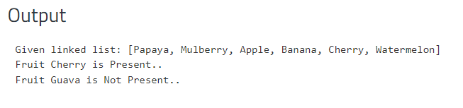

Solution

Question 2
50 Marks
Write a Java program to replace an element in a linked list. Please insert a screenshot showing the output of your program's execution

- The aim is to define a class named Replace_Element.
- Create a LinkedList object named fru_list with a type parameter of String, indicating that it will store strings as its elements.
- Add the Strings elements such as "Watermelon", "Apple", "Cherry", and "Banana" to fru_list .
- Print the initial contents of fru_list before any modifications.
- Replace the element at index 2 in fru_list with the string "Pineapple". The set method takes two parameters: the index at which the element needs to be replaced, and the new value to be inserted at that index.
- Print the message "Replace an Element in a linked list."
- Print the contents of fru_list after replacing the element, which will now include "Pineapple" at index 2.
- The output of the program will be the initial contents of fru_list printed on the first line, followed by the message "Replace an Element in a linked list." printed on the second line, and the updated contents of fru_list with "Pineapple" at index 2 printed on the third line.
- Typical output
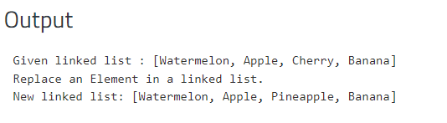
Solution

